**Republic of the Philippines**

**CEBU TECHNOLOGICAL UNIVERSITY**

**College of Computer, Information, and Communication Technology**

Cemetery Management System

In Partial Fulfillment of

Bachelor of Science in Information Technology

CC225 Information Management

Submitted To:

Mr. Gibe S. Tirol

Submitted By:

Decinan, Johnbert

Luvindino, Zildjan Leenor

Manatad, Venice

Republic of the Philippines

**CEBU TECHNOLOGICAL UNIVERSITY**

MAIN CAMPUS

M.J Cuenco Avenue Cor. R. Palma Street, Cebu City, Philippines

Website: <http://www.ctu.edu.ph> E-mail: mis@ctu.edu.ph

**COLLEGE OF COMPUTER, INFORMATION AND COMMUNICATIONS TECHNOLOGY**

CC225

INFORMATION MANAGEMENT

2ND SEMESTER, AY 2022 – 2023

BSIT II - B

**NAMES:**

DECINAN, JOHNBERT.

LUVINDINO, ZILDJAN.

MANATAD, VENICE.

**SUBMITTED TO**:

MR. GIBE S. TIROL

table of contents

A. DATABASE INITIAL STUDY 1

I. SITUATION 1

II. PROBLEM AND CONSTRAINT 2

III. OBJECTIVES 3

IV. SCOPE AND BOUNDARIES 3

V. FUNCTIONALITIES 4

B. CONCEPTUAL DESIGN 5

I. BUSINESS RULES 5

II. ERD 6

1. EXTERNAL MODEL 6

2. CONCEPTUAL MODEL 7

III. DATA DICTIONARY 8

IV. EERD 9

V. DBMS SELECTION 10

C. INTERNAL MODEL 11

D. PHYSICAL DATABASE MODEL 13

E. PROTOTYPE 14

# DATABASE INITIAL STUDY

## SITUATION

A family is visiting a cemetery to pay their respects to their loved one who passed away several years ago. At the same time, they are looking to purchase a burial plot for a loved one who just passed away. However, when they arrive at the cemetery, they realize they do not remember the exact location of their loved one's burial plot. They approach the cemetery staff to ask for assistance, but the staff is unable to locate the grave because the paper records are disorganized and incomplete.

With the cemetery management system, the family member can easily search for available plots, view their prices, and book for the preferred burial plot. The system will provide real-time information on the availability of plots and ensure that the booking process is efficient and error-free. They can also access personal information about their beloved loved ones whom they want to visit, such as their name, date of birth, date of death, and location of burial plot, providing a more meaningful and personalized experience.

The cemetery management system will be responsible for managing the records of burial plots, including the personal information of the deceased, the date of interment, date of exhumation, and the location of the plot. The system will also track the availability of plots and manage the booking of new plots. It will improve the efficiency of cemetery operations and provide a better experience for visitors.

## PROBLEM AND CONSTRAINT

The current system for managing cemetery records is outdated and inefficient. It relies on paper records, making it difficult to track and manage the status of burial plots. There is also limited access to information for visitors, making it challenging to locate specific burial plots.

Possible problems that a cemetery management system wants to solve are:

**Inefficient and outdated record-keeping:** Traditional paper-based record-keeping systems can be disorganized and difficult to manage, leading to errors and inaccuracies in the cemetery records. A cemetery management system provides a digital record-keeping system that is easier to manage and track, reducing the risk of errors and inaccuracies in the cemetery records.

**Difficulty in locating burial plots:** Visitors may have difficulty locating the burial plot of their loved ones due to the size of the cemetery or disorganized paper records. A cemetery management system provides search function to easily locate burial plots, providing a better experience for visitors.

**Access to information:** Visitors may have limited access to information about their deceased loved ones, the cemetery management system provides an interface where the visitors can easily search for the information of their loved one including their exhumation date.

**Compliance with data privacy laws:** The handling of sensitive personal information is subject to data privacy laws. A cemetery management system ensures compliance with data privacy laws and protects sensitive personal information, providing a secure and trustworthy system for visitors and cemetery staff

## OBJECTIVES

The main objective of the cemetery management system is to provide an efficient and effective platform for managing cemetery records and providing information to visitors. The system aims to:

• Improve the accuracy and reliability of cemetery records management.

• Implement a search functionality for the convenient location of burial plots of the deceased loved ones.

• Provide information for visitors to access loved one’s cemetery details.

• Facilitate access to information pertaining to plot booking/reservation.

## SCOPE AND BOUNDARIES

**SCOPE**

The cemetery management system will be designed for a specific cemetery and will be used by both cemetery staff and visitors. The system will be responsible for managing burial plot records, including personal information of the deceased, the location of the plot, and the date of interment and exhumation. The system will also manage the booking of new plots and track the availability of plots.

**BOUNDARIES**

The peripherals to be used for this system are:

* CPU (at least 6th generation)
* 8 GB RAM
* 500 GB ROM
* Windows Operating System (Windows 8 and above)

## FUNCTIONALITIES

Functionalities for Cemetery Staff:

* **Plot management:** ability to add, update, or delete burial plot records, including personal information of the deceased, location of the plot, date of interment, and date of exhumation.
* **Booking** **Management**: ability to manage the booking of new burial plots and track the availability of plots.
* **Record** **Management**: ability to manage decease’s information, including adding, updating, or deleting decease’s information.
* **Data** **privacy**: ensure compliance with data privacy laws and protect sensitive personal information.

Functionalities for Customer:

* **Burial plot locator:** ability to locate burial plots using a search function.
* **Record Search:** access to personal information of the deceased, including their name, date of birth, date of death, location of burial, and date of interment.
* **Cemetery Information Access**: access to information about the cemetery, including its history, hours of operation, and contact information.
* **Plot Booking/ Reservation:**ability of the visitors to book for the preferred plot given their prices and ability to reserve a plot for their deceased loved ones.

# CONCEPTUAL DESIGN

## BUSINESS RULES

A USER can be an ADMIN.

An ADMIN must be a USER.

An ADMIN manages one or many RECORD.

A RECORD is managed by one ADMIN.

A USER can be related to one or more RELATIVE

A RELATIVE is related only to one USER

A USER can place one or more TRANSACTION.

A TRANSACTION is placed by a USER.

A TRANSACTION can have none or one RELATIVE.

A RELATIVE can only be placed on one TRANSACTION.

A PLOT is placed to none or many TRANSACTIONS.

A TRANSACTION has none or one PLOT placed.

A PLOT is stored once or many times on RECORD

A RECORD stores only unique PLOT

RELATIVE is recorded once or more on RECORD.

A RECORD has only one RELATIVE.

## ERD

### EXTERNAL MODEL

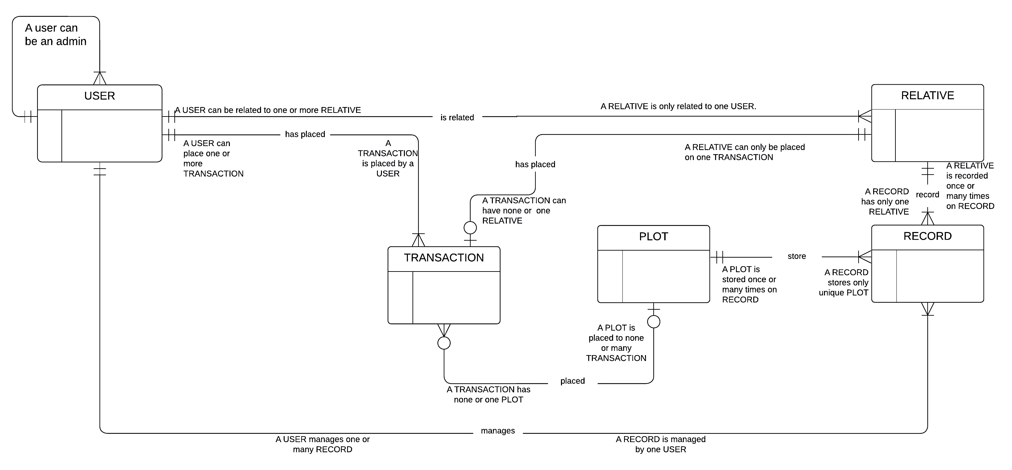

### CONCEPTUAL MODEL

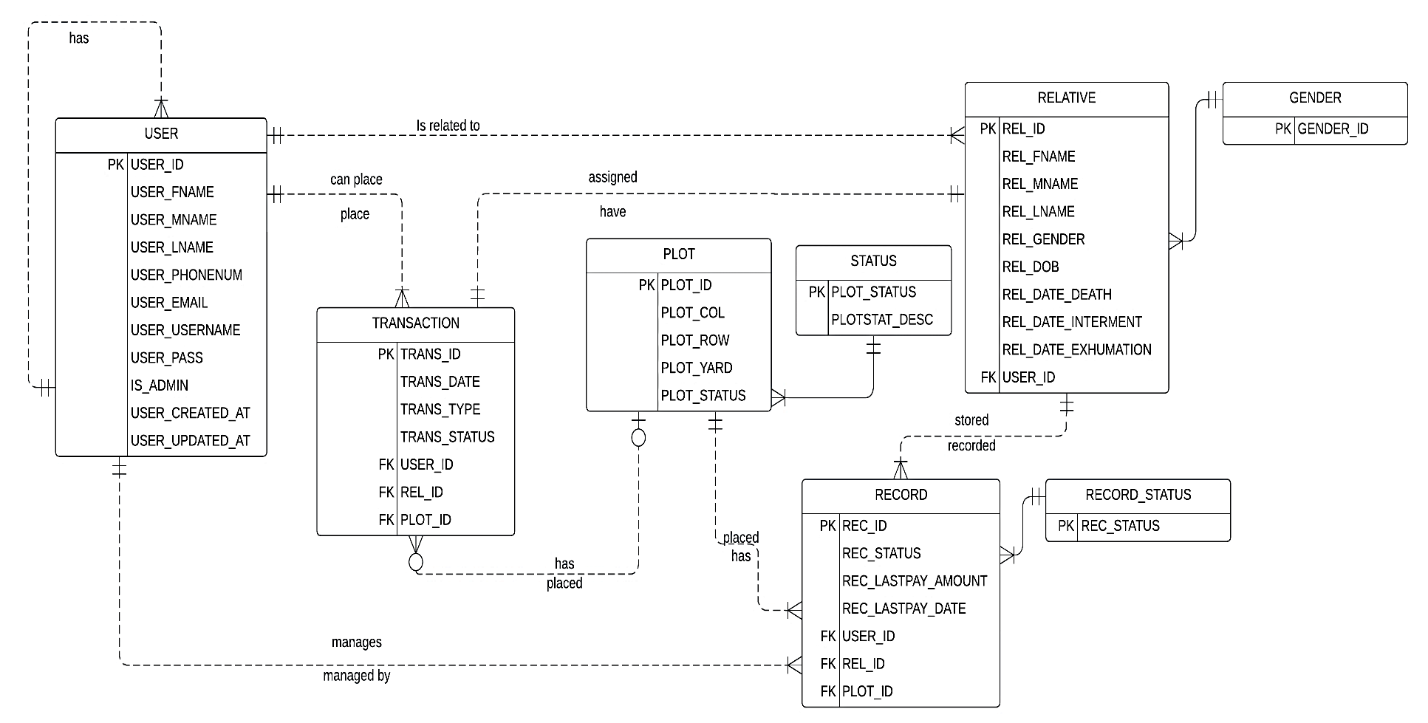

## DATA DICTIONARY

## EERD

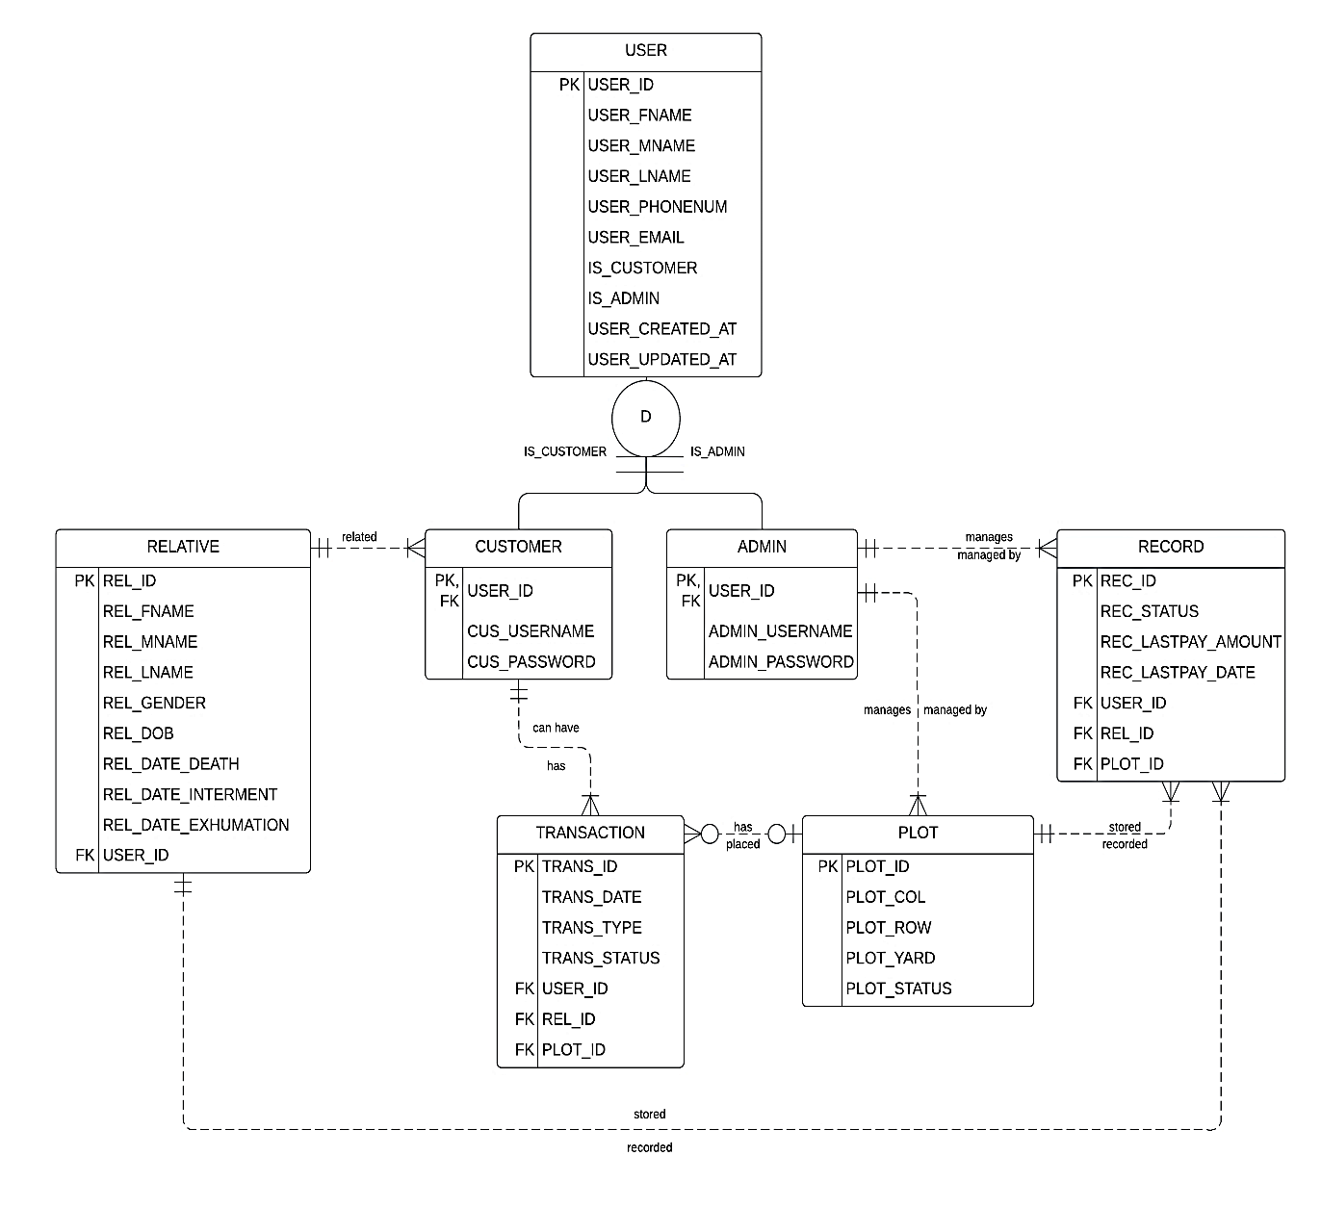

## DBMS SELECTION

PostgreSQL, or "Postgres," is an open-source database system that is available to the public at no cost. It functions alongside the SQL language but incorporates additional features of its own. With a history of more than three decades, PostgreSQL has undergone continuous development and enhancements, establishing itself as a dependable and effective option for data management. In essence, it serves as a reliable tool for storing, organizing, and efficiently manipulating substantial volumes of data.

**ADVANTAGES OF POSTGRESQL**

**Open Source:** PostgreSQL is an open-source database system, meaning it can be used without any licensing fees and can be customized to meet specific requirements. Its open nature allows developers worldwide to contribute to its development and improvement.

**Reliability and Stability:** PostgreSQL is renowned for its reliability and stability, making it a trusted choice for businesses relying on their databases for daily operations. It maintains data integrity and remains stable even under heavy data loads.

**Extensibility:** Users of PostgreSQL can create their own data types, operators, and functions using various programming languages. This high level of extensibility makes it adaptable and customizable to suit specific needs.

**High Scalability:** PostgreSQL is designed to handle substantial amounts of data while maintaining excellent performance. Whether dealing with small data volumes or terabytes of information, PostgreSQL is capable of scaling according to the requirements.

**Comprehensive Security Features:** PostgreSQL incorporates robust built-in security features, including a strong access-control system, views, granular permissions, and built-in SSL support. These features ensure data security and limit access to authorized individuals only.

# INTERNAL MODEL

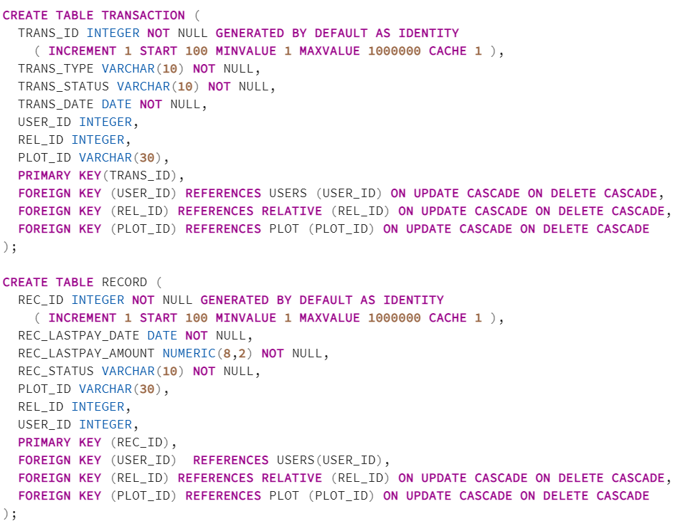

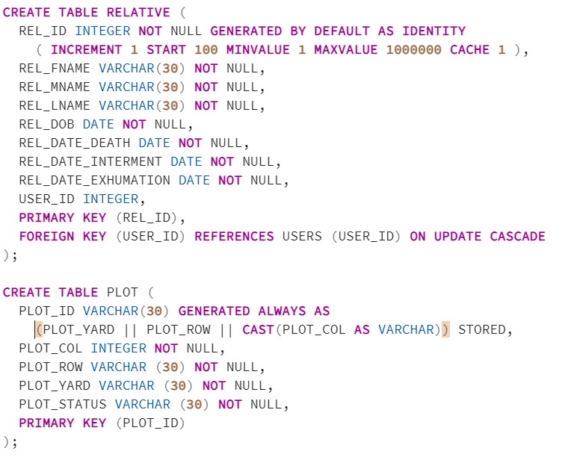

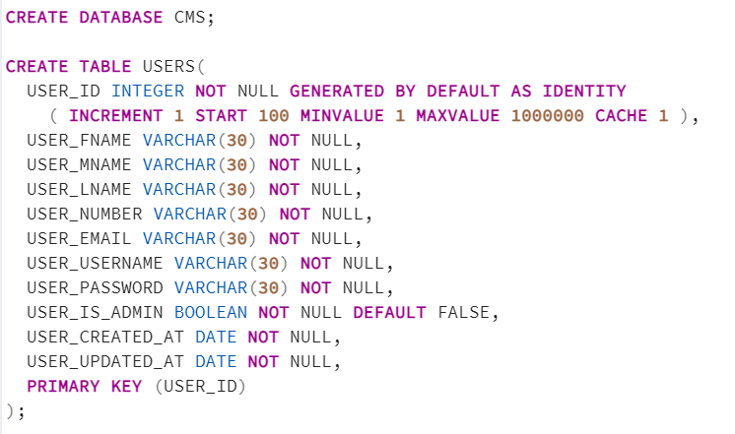

# PHYSICAL DATABASE MODEL

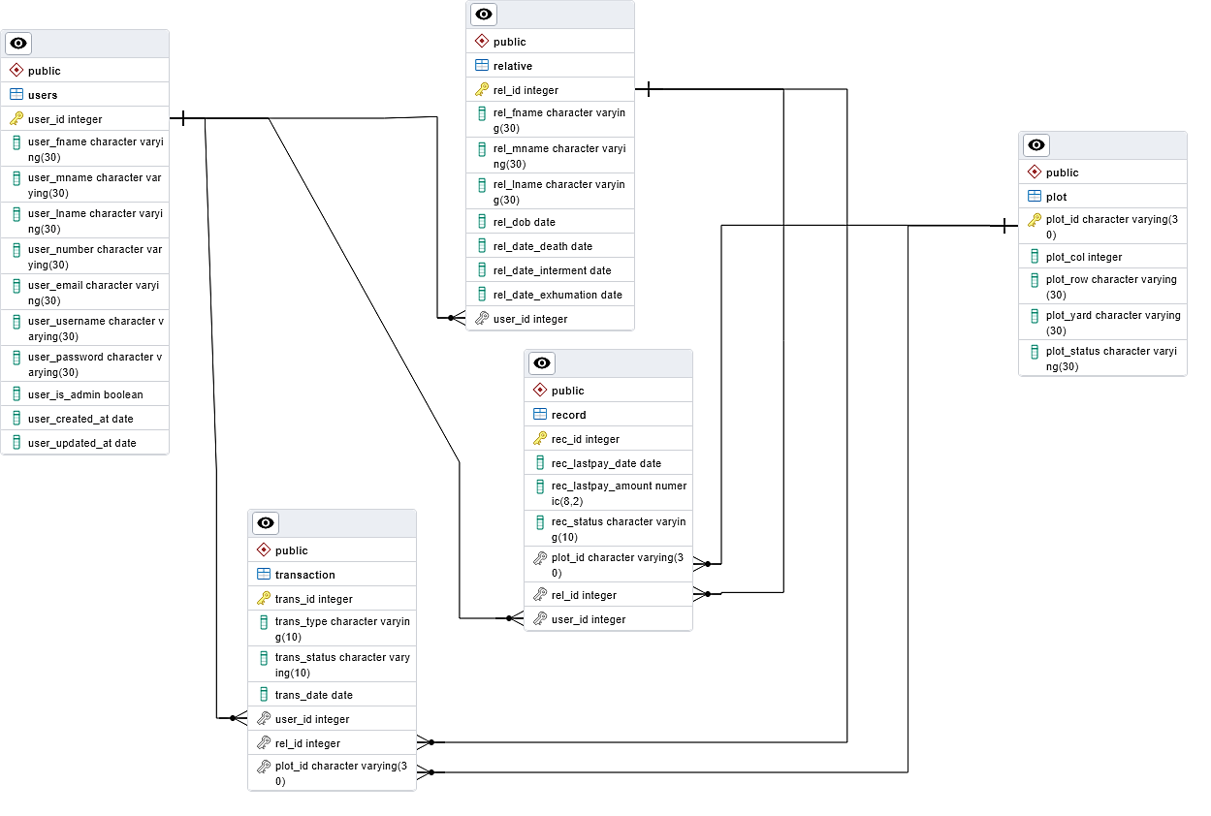

# PROTOTYPE

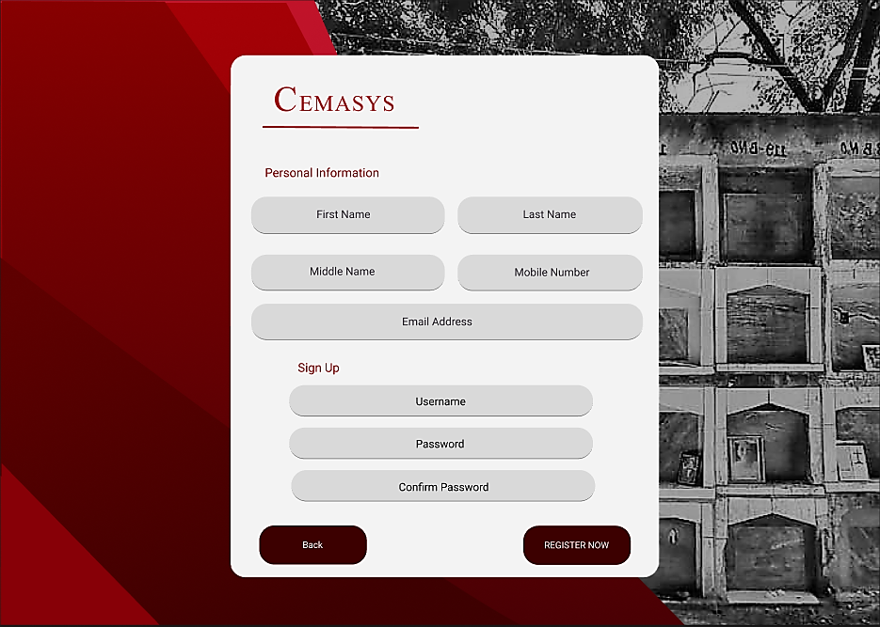USER

Sign up page where users can sign up

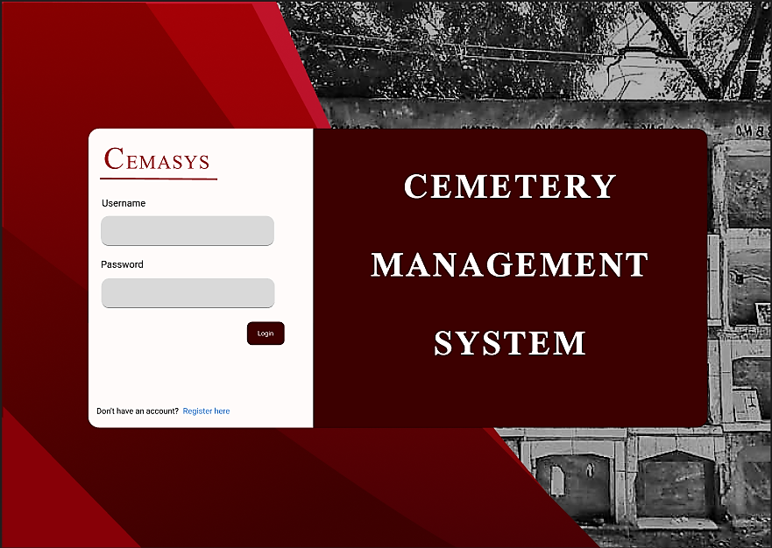Log in page where users/admin can log in

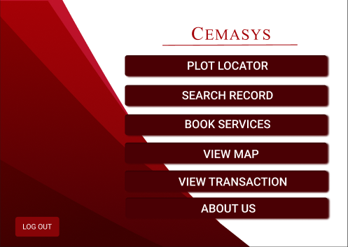 User’s homepage where they can use the features offered.

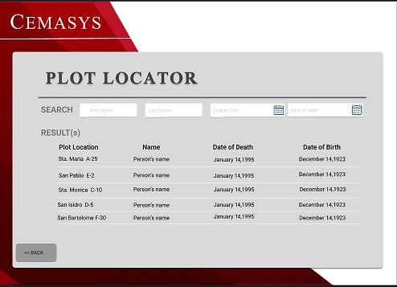 Plot locator feature to locate where relatives are placed

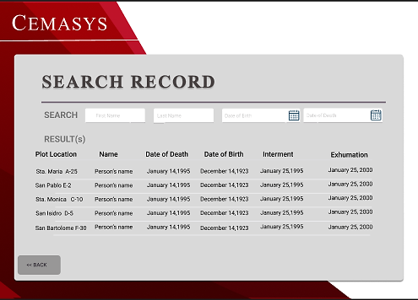

Search record feature to view information on relative

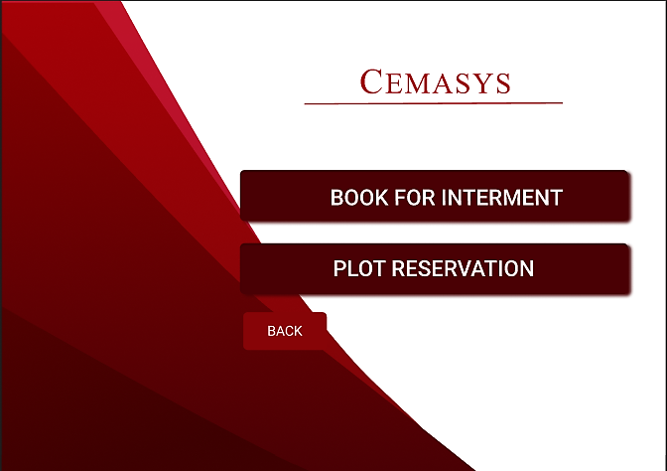

Services Menu

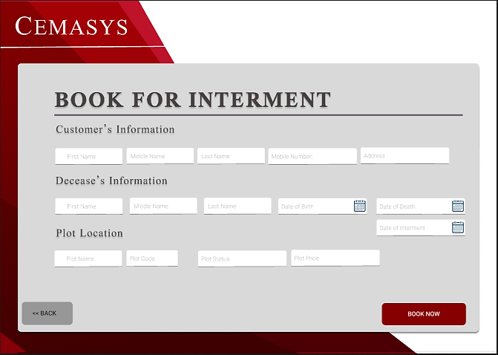

Book interment feature for burial of a relative

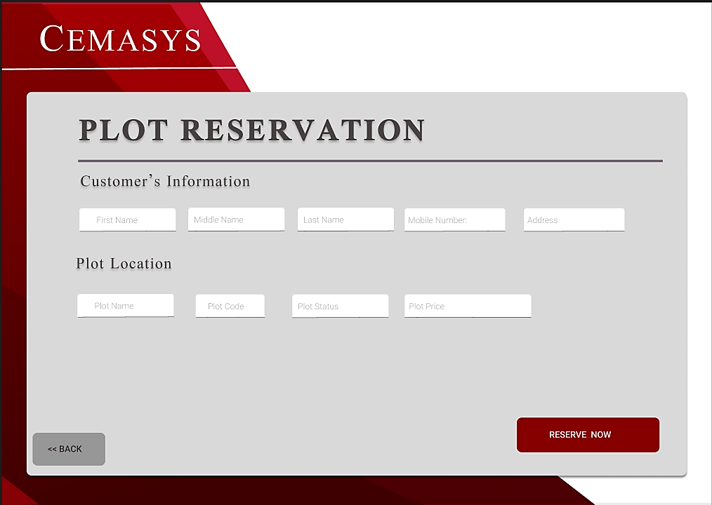

Plot Reservation for users

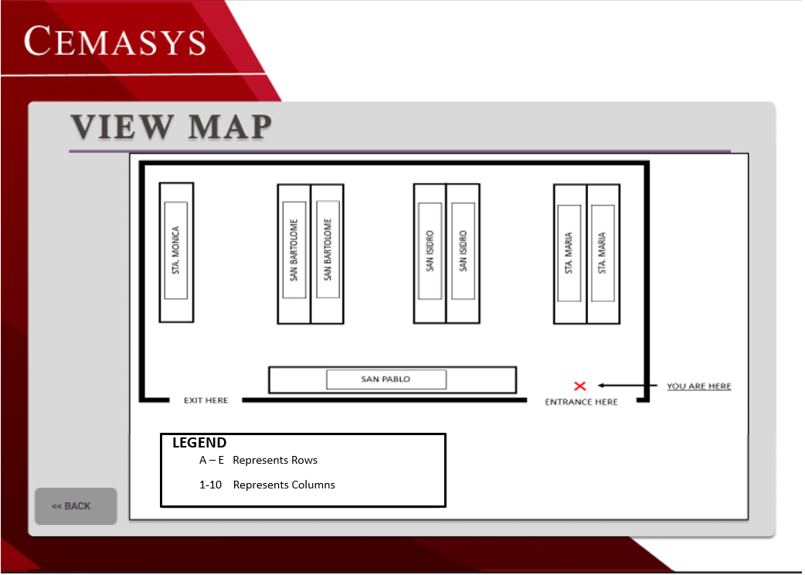

View Map feature for guiding users on site.

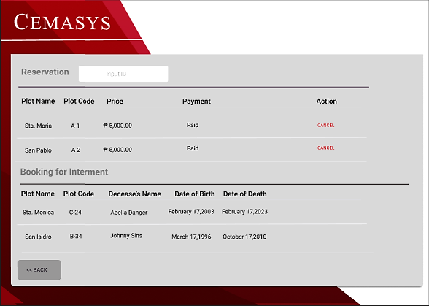

View Transactions to keep track of every transaction

**ADMIN**

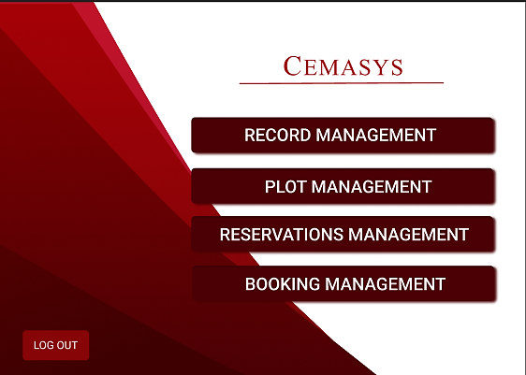

Login page where admin can login

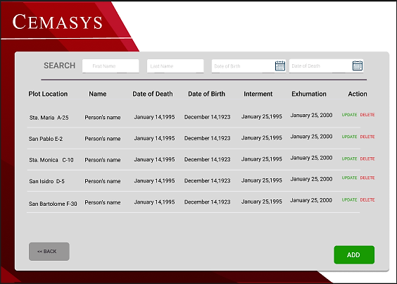

Record Management to manage all records of the deceased

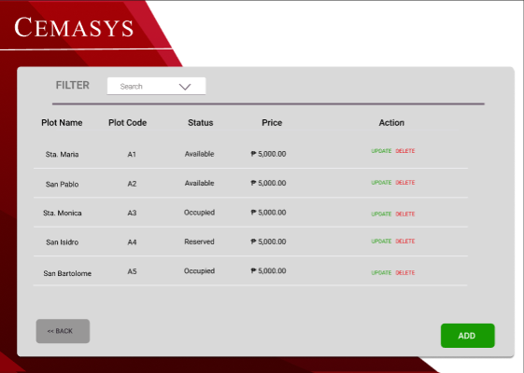

Plot Management for admins to manage all plots

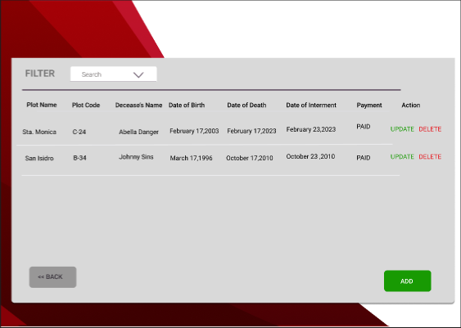

Booking Management to manage all bookings made by users

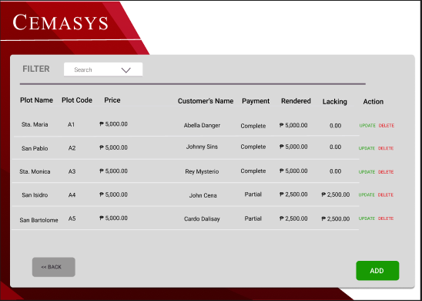

Reservations Management feature for all reservations.